- Creating a Sequence

Estimated time
01:00

What this exercise is about
This exercise covers the whole process of creating, compiling, running, and monitoring a DataStage Sequence job.

What you should be able to do
At the end of this exercise, you should be able to:
- Design a Job Sequence that runs two jobs
- Pass parameters from the Job Sequence to the Job Activity stages
- Compile a job
- Run a job
- View messages written to the job log

Introduction
Sequence jobs are master jobs that run batches of DataStage jobs, including other Job Sequences. Here the focus is on building a Job Sequence, not on the jobs it runs

Requirements
Jobs Job_JDBC_File and Job_JDBC_Transformer from previous exrcises are completed and ran successfully.

Task: Create a sequence job
- Open the project created in the previous task.
- Click on Jobs tab after the project is opened.

- While in Jobs tab click on Create + button. A drop will appear, now click on Sequence job. In this sequence we are going to run first Job_JDBC_File and Job_JDBC_Transformer after that
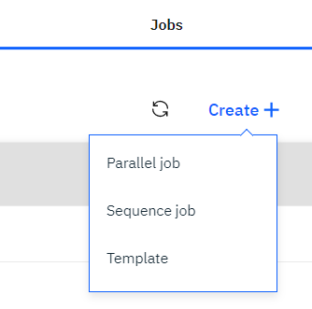
- Now you can see the below screen
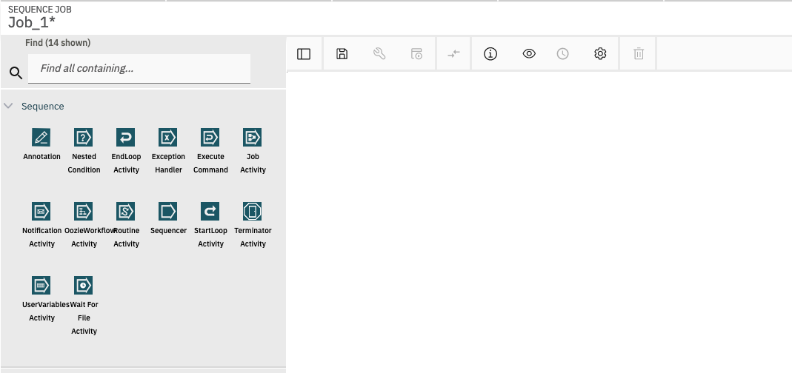
- Now click on Job Activity in the palette and drag the same on to canvas
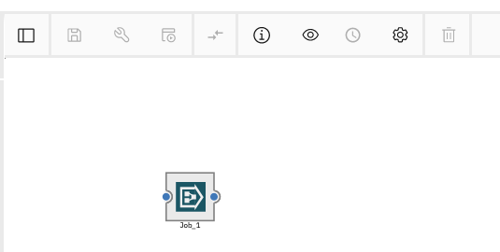

- Now click on Job Activity again and drag the same to canvas. You might see a link has already been established between Job_1 and Job_2 stages. It can be turned off by unchecking Smart stage suggestions option from the Settings.
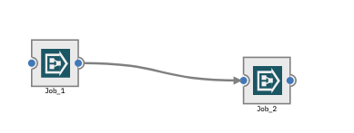

- Now save the job by clicking on the save icon. Save new job window will appear. Give job name as Seq_RunJobs and let the Category be \Jobs and click on the Save button.

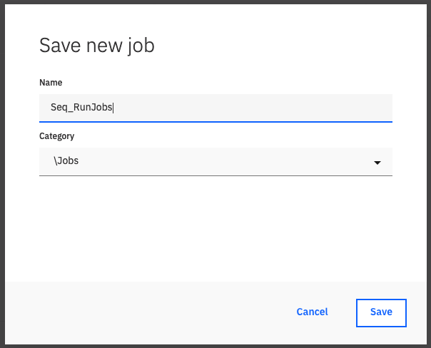

- Save the job by clicking on the save icon. Name it as Seq_RunJobs.

- Double-click on the stage Job_1 from canvas and properties section will open.
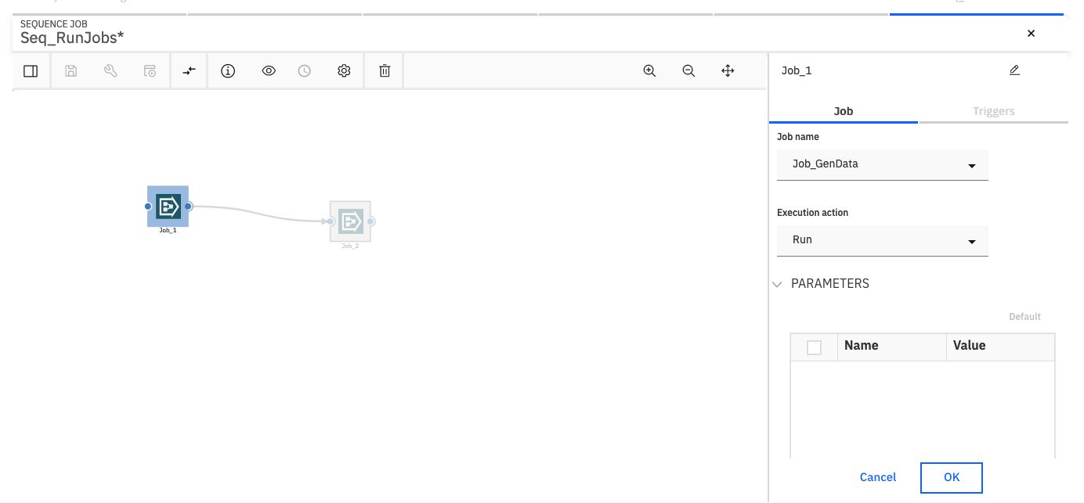
- Change the name of the Job Activity stage from Job_1 to Job_JDBC_File. You can rename it at the top of the stage window.
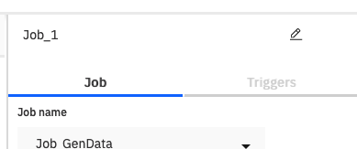

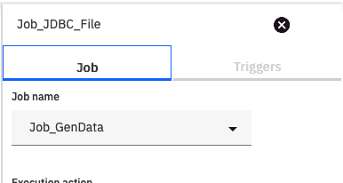
- Select the Job Job_JDBC_File from the drop down

- By Default, Execution action will be set as Run. Click on Execution action and select Reset if required, then run
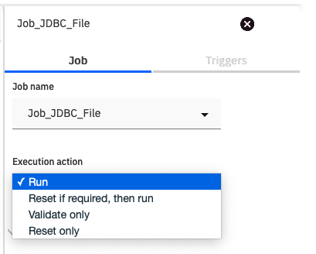
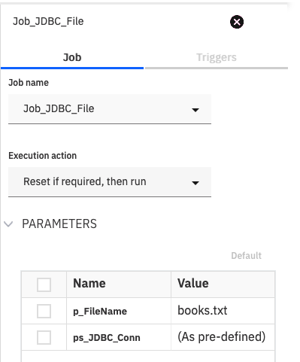

- Click on Triggers
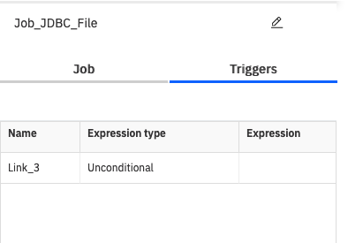

- From the Expression Type drop down, select OK – (conditional)
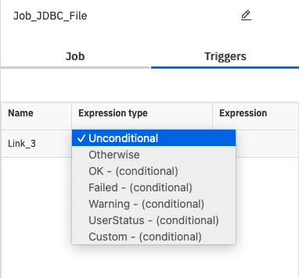
- Click on OK.

- Double-click on the stage Job_2 from canvas and properties section will open.
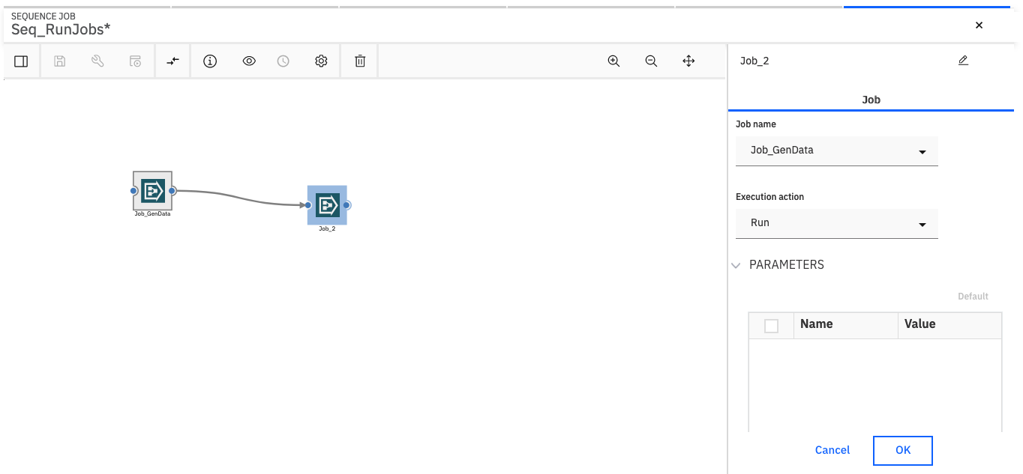

- Change the name of the Job Activity stage from Job_2 to Job_JDBC_Transformer rename it at the top of the stage window.
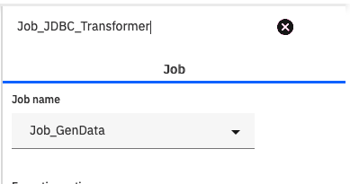

- Select the Job Job_JDBC_Transformer from the drop down
- By Default, Execution action will be set as Run. Click on Execution action and select Reset if required, then run
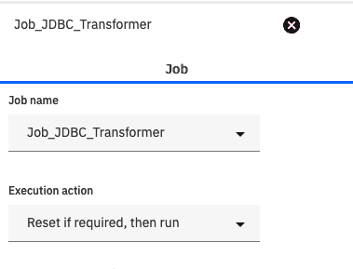
- Click on OK.
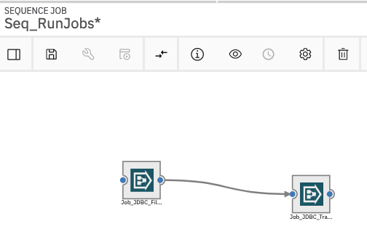
- Click on the save icon to save the job
Task: Compile, run, and monitor the job
- Click on the Compile icon to compile your job. If your job compiles with errors, fix the errors before continuing.

- If the job compiles successfully, you’ll see the message Compiled Successfully and View Code link will appear.
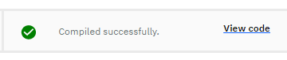
- Click the Run icon to run the job

- Once you click on the Run icon, Job run options window will appear. Click on Run button.
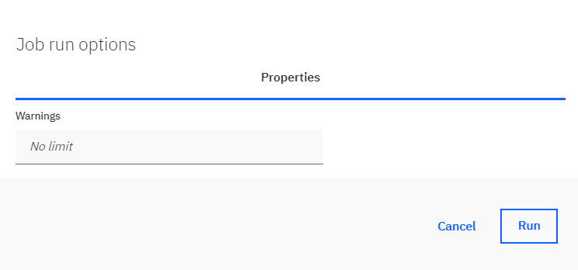

- After the job is run, you can see whether the job ran successfully or not along with the Log link.
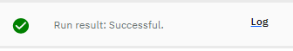
- Click on the Log link to view the logs in Data Flow Designer.
